

Emergency
Asthma
Guideline

Management of the Acute Adult Asthma Patient

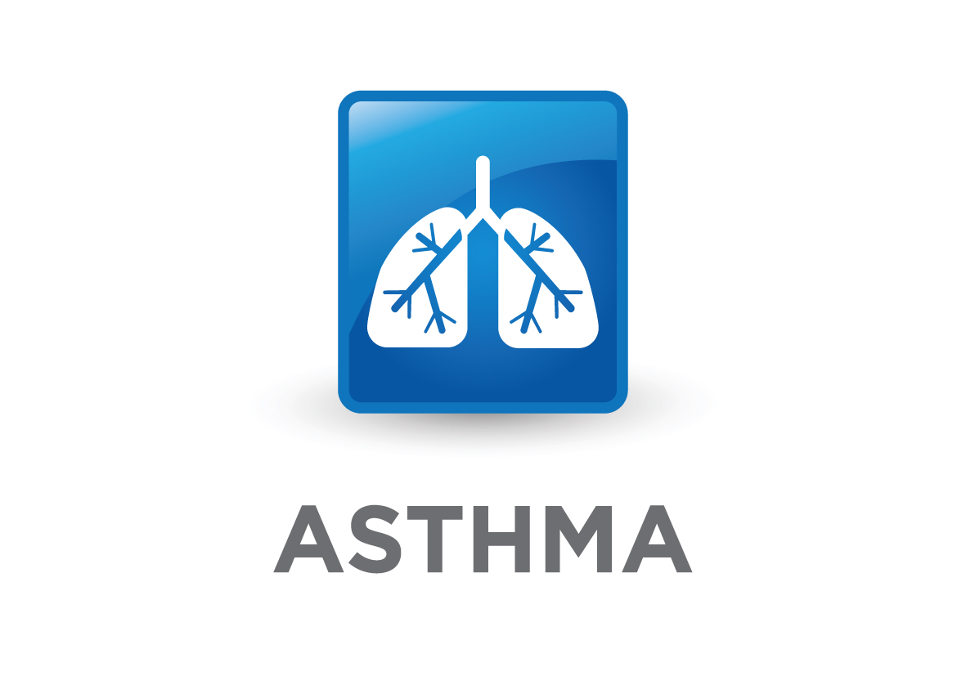
HSE National Asthma Programme

Published January 2012

Document Development and Control

Document reference number: | ACUTEMGTGUIDE001 | Document drafted by: | National Asthma Programme Working Group
Revision number: | 1.0 | Responsibility for Implementation: | Local Hospitals delivering Asthma Services
Date of Last Update: | 12th January 2012 | Responsibility for evaluation and audit: | National Asthma Programme
Document Status: | For Publication | Group Status: | Feedback from RCPI/ITS Clinical Advisory Group  Feedback from EMP  Feedback from AMP  Feedback from PHECC  Feedback from ICGP
Approval date: | 15th August 2011  12th January 2012 | Approved by: | HSE, RCPI / ITS CAG,  HSE Clinical Strategy and Programme Directorate  Dr. Barry White
Revision date: | June 2013 | Pages: | 40
Table of Contents

1 Introduction and Background 4
1.1 Purpose 4
1.2 Scope 4
1.3 Glossary of terms and Definitions 4
1.4 Policy Statement 5
1.5 Stakeholders Roles and Responsibility 6
2 Acute Adult Asthma Guideline 8
2.1 Self Treatment by Patients developing acute asthma exacerbation 8
2.2 Primary Care and GP out of hours management of acute asthma exacerbations 8
2.3 Pre Hospital management of acute asthma exacerbations 9
2.4 Hospital Admission Criteria 10
2.5 Initial Assessment 11
2.6 Objective Assessments of the Adult Asthma Patient 13
2.7 Acute Treatment of the Adult Asthma Patient during an Exacerbation 14
2.8 Discharge and follow-up planning 18
2.9 Appendices 19
2.10 Implementation Plan 20
2.11 Evaluation and Audit 20
2.12 Guideline Development 21
2.13 Evidence Base 21
3 Appendix i - Emergency treatment protcols 22
4 Appendix II – emergency Treatment Care bundles 27
5 Appendix III - Discharge Letter, Fax, Email Template 33
6 Appendix IV – Audit Form for emergency Asthma Care 34
7 Appendix V - Asthma Management Plans 35
8 Appendix VI – Peak Flow Measurements 37
9 Appendix Vii – medications in acute asthma 38
10 Appendix VIII – acknowledgements 39

Introduction and Background

Purpose
The purpose of this guideline is to outline the standard treatment protocols for emergency and acute management of an asthma adult patient in an Irish healthcare setting.

Scope
The scope of the National Asthma Clinical programme is to ensure the management of asthma is based on current international evidence-based care in all care settings including primary care. These guidelines are for the management of Acute Adult Asthma. There are separate Acute Pediatric guidelines.

Glossary of terms and Definitions

NAP National Asthma Programme
RCPI Royal College of Physicians Ireland
ICGP Irish College of General Practitioners
ED Emergency Department
AMU Acute Medical Unit
MAU Medical Assessment Unit
OOH GP Out of Hours Service
GP General Practitioner
PN Practice Nurse
CNS Clinical Nurse Specialist in Respiratory care
PEF Peak Flow Measurement
FEV1 Forced Expired Volume per second
SPO₂ Oxygen Saturation as a percentage

Policy Statement
It is the policy of the National Asthma Programme (NAP) that assessment and management of acute asthma exacerbations should be undertaken according to the best available clinical evidence which is outlined in this document.
Confidential enquiries into asthma deaths or near fatal asthma exacerbations from the UK and also Republic of Ireland have identified a number of factors which contribute to an asthma death. Most deaths from asthma occur before admission to hospital, and are usually in patients who have chronic asthma, who are on inadequate inhaled corticosteroid therapy with increased reliance on inhaled β₂-agonists. There is generally poor perception by the patient or physician caring for the patient of the overall severity of the asthma exacerbation. In addition, inadequate management in the acute event including using sedation in some cases are also factors linked to asthma deaths.
Typically most exacerbations have a progressive onset although a few can occur rapidly. Most attacks of asthma severe enough to require hospital admission have developed relatively slowly over a period of six hours or more and even up to 48 hours so there is often time for effective action to reduce the number of hospitalisation for acute asthma. There are many similarities between those patients who die from asthma or who have had a near-fatal asthma episode and those patients who are admitted to hospital with a severe asthma exacerbation.
Respiratory distress is common during exacerbations along with decreases in lung function (FEV1 or PEF). Measurement of lung function is a more reliable indicator than symptoms of an attack severity. Severe exacerbations are potentially life-threatening and their treatment requires close supervision. Patients or care givers should be taught to recognise a severe attack and to see their doctor promptly when this occurs or to proceed to nearest ED that provides emergency access for patients with acute asthma. Strategies for treating different levels of asthma exacerbations are outlined in this Emergency Asthma Care document to be adapted and implemented at a local level.
In terms of follow up after discharge, patients should be seen promptly by their GP and a respiratory specialist should follow up patients admitted with severe asthma for at least one year after the admission.

Stakeholders Roles and Responsibility
The roles and responsibilities of all stakeholders involved in the lifecycle of the guideline are detailed below. This is not an exhaustive list.
Process  Responsible | Applying the protocol | Auditing Use of protocol | Developing/Updating protocol | Reviewing the protocols
General Practitioners
Practice Nurses
Out of Hours Staff
Community Pharmacist
Pre Hospital emergency care practitioners
ED/AMU Physicians
ED/AMU Nursing Staff
Specialist Respiratory Teams
Clinical Audit Services
ICGP Quality in Practice Committee
National Asthma Clinical Care Programme
Pre hospital emergency care council
Patient Organisation

Acute Adult Asthma Guideline

Self Treatment by Patients developing acute asthma exacerbation
Patients with asthma including all patients with severe asthma, should have an agreed written asthma management plan and their own peak flow meter, with regular checks of inhaler technique and compliance at every clinical assessment with the healthcare system.
Patients should know when and how to increase their medication and when to seek medical assistance. This should be contained within the written asthma management plan with treatment steps clearly illustrated. Such plans can decrease hospitalisation for and deaths from asthma.
All personnel who may be in contact with an acute asthma patient with increased symptoms e.g. GP practice receptionists, pre-hospital emergency service staff, out of hours staff and community pharmacists, should be aware that asthma patients complaining of respiratory symptoms may be at risk and should have immediate access to a physician or a nurse trained in acute asthma management.
The assessments required to determine whether the patient is suffering from an acute attack of asthma, the severity of the attack and the nature of treatment required are detailed in this guideline. It may be helpful to use a systematic recording process. Proformas such as protocols and care bundles in appendix I and II have proved useful in acute asthma management.

Primary Care and GP out of hours management of acute asthma exacerbations
The vast majority of acute asthma exacerbations are managed at Primary Care level including Out of Hours (OOH) settings. These exacerbations are characterized by symptoms including shortness of breath, cough, wheezing or chest tightness, or a combination of these symptoms. Deaths from asthma while uncommon do occur usually in association with an acute exacerbation and are often contributed to by lack of awareness of the doctor to the severity of the exacerbation.

Risk factors for developing fatal asthma
- Previous near fatal asthma
- Previous admission/A+E visit with asthma, especially if within past 12 months.
- Requirement of more than 3 classes of asthma medication
- Heavy use of short acting β₂-agonists

Other issues having an adverse effect on asthma include:
- Non adherence with regular asthma therapy
- Failure to attend for regular follow up after an exacerbation
- Self discharge from hospital following an exacerbation
- Psychological issues
- Drug/Alcohol abuse
- Obesity
- Learning difficulties
- Social issues

Some key points when dealing with an exacerbation include:
- It is important to take a good history from the patient
- Identify when symptoms started ?
- How have symptoms progressed?
- What therapy has the patient taken to deal with asthma symptoms to date?
- Has a similar episode occurred in the past

It is important to be aware that patients symptoms may underestimate the severity of the attack and it is important to have objective measurements of the event, to include:
- Peak expiratory flow (PEF) or FEV1
- Respiratory rate
- Heart rate
- Oxygen saturation (when available)

The severity of asthma exacerbation can be categorized according to the algorithm.

The treatment can be followed according to Section 3.1

Recommendations:

Ongoing education of practice staff in dealing with acute asthma should be in place. This involves doctors, nurses and practice reception/telephone staff to ensure that asthmatic patients are offered prompt appointments.

There needs to be support to allow patients who are seen in an acute event to be followed up to offer structured care and education. This may involve making contact per phone or flagging notes when patient attends again for any reason including repeat prescriptions.

Pre Hospital management of acute asthma exacerbations
Always dial 999/112 if:
- Symptoms persist
- No immediate improvement in symptoms after initial treatment or within 5 minutes after treatment
- Too breathless or exhausted to talk
- Lips turn blue
- Or if in doubt
Most deaths from asthma occur before admission to hospital.
Protocols for the emergency treatment of asthma exacerbations in the pre-hospital setting can be found in appendix iii or via the Pre- Hospital Emergency Care Council, clinical practice guidelines at www.phecc.ie.

Hospital Admission Criteria

- Admit patients with any feature of a life threatening or near-fatal attack.
- Where available a specialist respiratory opinion should be sought and the patient admitted to the respiratory unit.
- Admit patients with any feature of a severe attack persisting after initial treatment.
- Patients whose peak flow is greater than 75% best or predicted one hour after initial treatment may be discharged from ED unless they meet any of the following criteria, when admission may be appropriate:
- still have significant symptoms
- concerns about compliance
- living alone/socially isolated
- psychological problems
- physical disability or learning difficulties
- previous near-fatal or brittle asthma
- exacerbation despite adequate dose steroid tablets pre-presentation
- presentation at night
- pregnancy
Asthma exacerbations (attacks of acute asthma) are associated with progressive increase in asthma symptoms (typically, shortness of breath (SOB), cough, wheeze, chest tightness or any combination of these) but the patient’s own perception of asthma symptoms in some cases may be poor and thus unreliable. In addition to symptoms there is usually an objective decrease in expiratory flow rates on lung function testing this should be quantified by PEF or spirometry (FEV1). The PEF or FEV1 expressed as percentage (%) of personal best is the most useful clinically but in the absence of this the % predicted value is a rough guide. Of note a reduction to 50% or less from predicted or best values indicates a severe attack. Pulse oximetry can be of use as low oxygen levels may indicate the necessity for referral to hospital but normal levels greater than 92 % DO NOT EXCLUDE A SEVERE ASTHMA ATTACK.
These measures along with history, examination, pulse and respiratory rate and response to treatment are all required to determine the need for hospitalisation or risk of relapse after acute management.
The assessment and management should follow guidelines outlined in the following acute asthma management protocols.
The SEVERITY evaluation of an exacerbation is important and should be determined as to whether it is mild, moderate, severe or life-threatening.
Severe or life-threatening exacerbations require close observation and should be referred to an Emergency Department (ED).
Patients with life threatening features at any time during the initial assessment in ED should be admitted to hospital for at least 24 hours.
In addition, patients with severe features persisting after the first salbutamol nebulisation should be considered for an admission of over 24 hours until stable.
OVER 1 PATIENT DIES EVERY WEEK FROM ASTHMA in the Irish population and Patients at high risk of asthma deaths include those with:
- History of near fatal asthma requiring intubation or of mechanical ventilation
- Hospital admission or ED attendance in past year
  - Those using or recently stopped oral steroids
  - Over use of β₂-agonists (more than 1 inhaler per month)
  - Psychiatric disease or psychosocial problems including sedative use
  - History on non-compliance with asthma medication plan
Recognition of acute asthma is done by assessing the level of severity of the patient and this includes the clinical history, examination, (including chest, pulse and respiration rates), peak flow rates (PEF) with peak flow meter and oxygen saturation (SaO₂) with an oximeter.

Initial Assessment
Delay in treatment and under-dosing in an asthma attack can adversely affect outcomes. By using objective measures, the level of asthma severity is less likely to be underestimated. This will enable prompt treatment at the right dose to be effective. An example assessment form template which can be used for your records or adapted to suit your needs, is enclosed within the appendices of this pack. It can also be used for audit purposes to:
- indicate which areas of assessment are commonly missed
- help with staff training
- Audit risk factors in people with asthma frequently attending for an asthma attack.
In acute asthma it is important to assess and record the level of severity as in the following tables.

Levels of Severity for Adults
Level of Severity | Life Threatening Asthma Features
Peak Flow Rate (PEF)  Oxygen Saturation SpO2  Speech  Respiratory Examination  Pulse  BP | PEF < 33% best or predicted  SpO2 <92%  Unable to talk - Exhausted, confusion, or coma  Poor respiratory effort, silent chest, cyanosis  Bradycardia, arrhythmia,  Hypotension
Severe Asthma Features
Life Threatening Features  Peak Flow Rate (PEF)  Oxygen Saturation SpO2  Speech  Respiratory Examination  Pulse  BP | No life threatening features  PEF 33–50% best or predicted  SpO2 >92%  Cannot complete sentence in one breath  Respiration Rate>25 breaths/min  Pulse Rate > 110 beats/min  Normal
Moderate Asthma Features
Life Threatening Features  Peak Flow Rate (PEF)  Oxygen Saturation SpO2  Speech  Respiratory Examination  Pulse  BP | No life threatening features  PEF between 50-75% best or predicted  Greater than 92%  Talks in phrases, and prefers to sit,  Loud wheeze and Respiratory rate less than 25 breaths/min  Mild tachycardia but less than 110 b/min,  Normal
Mild Asthma Feature
Life Threatening Features  Peak Flow Rate (PEF)  Oxygen Saturation SpO2  Speech  Respiratory Examination  Pulse  BP | No life threatening features  Greater than 75% best or predicted  Greater than 92%  Talks in sentences and can lie down  Mild wheeze and respirations less than 25 B/min  Pulse is less than 100 b/min  Normal

Objective Assessments of the Adult Asthma Patient

Pulse Oximetry
Measure oxygen saturation (SpO₂) with a pulse oximeter to determine the adequacy of oxygen therapy and the need for arterial blood gas (ABG) measurement. The aim of oxygen therapy is to maintain SpO₂ 94-98%. In hypoxic patients it is important to consider alternative diagnosis e.g. Pneumothorax or pneumonia.

PEF or FEV₁
Measurements of airway calibre improve recognition of the degree of severity, the appropriateness or intensity of therapy, and decisions about management in hospital or at home. PEF or FEV₁ are useful and valid measures of airway calibre. PEF is more convenient in the acute situation. PEF expressed as a percentage of the patient’s previous best value is most useful clinically. PEF as a percentage of predicted gives a rough guide in the absence of a known previous best value. Different peak flow meters give different readings. Where possible the same or similar type of peak flow meter should be used.

Chest X-Ray
Chest X-ray is not routinely recommended in patients in the absence of:
- suspected pneumomediastinum or pneumothorax
- suspected consolidation
- life threatening asthma
- failure to respond to treatment satisfactorily
- requirement for ventilation
- However, in patients with an infiltrate on chest x-ray or high white cell count, antibiotics should be considered.

Blood Gases
Patients with SpO₂ less than (<) 92% (irrespective of whether the patient is on air or oxygen) or other features of life threatening asthma require ABG measurement. SpO₂ less than 92% is associated with a risk of hypercapnea. Hypercapnea is not detected by pulse oximetry. In contrast the risk of hypercapnea with SpO₂ greater than 92% is much less.

Acute Treatment of the Adult Asthma Patient during an Exacerbation
The primary therapies for the management of an exacerbation to relieve airflow obstruction and hypoxemia include:
- Repetitive administration of rapid-acting inhaled β₂-agonist bronchodilator
- Early introduction of systemic glucocorticosteroids
- Oxygen supplementation
- (The clinician may decide if antibiotic therapy is appropriate in some cases)

Oxygen

Many patients with acute severe asthma are hypoxemic (low blood oxygen). Supplementary oxygen should be given urgently to hypoxemic patients, using a face mask, Venturi mask or nasal cannula with flow rates adjusted as necessary to maintain SpO2 of 94-98%. Hypercapnea (raised blood CO₂ levels) indicates the development of near-fatal asthma and the need for emergency specialist/anaesthetic intervention. It is imperative to give supplementary oxygen to all hypoxemic patients with acute severe asthma to maintain a SpO₂ level of 94-98%. A lack of pulse oximetry should not prevent the use of oxygen.

Bronchodilators – repeated administration of rapid-acting inhaled β₂-agonist

In most cases inhaled β₂-agonists given in high doses act quickly to relieve bronchospasm with few side effects. There is no evidence for any difference in efficacy between salbutamol and terbutaline. Nebulised adrenaline (epinephrine), a non-selective β₂-agonist, does not have significant benefit over salbutamol or terbutaline.

In acute asthma without life threatening features, β₂-agonists can be administered by repeated activations of a pMDI via an appropriate large volume spacer or by wet nebulisation driven by oxygen, if available. Inhaled β₂-agonists are as efficacious and preferable to intravenous β₂-agonists (meta-analysis has excluded subcutaneous trials) in adult acute asthma in the majority of cases. Metered dose inhalers with spacers can be used for patients with exacerbations of asthma other than life threatening. The bronchodilator therapy delivered via a metered-dose inhaler (MDI), ideally with a spacer, produces at least an equivalent improvement in lung function as the same dose delivered via nebulizer. This route of delivery is the most cost effective, provided patients are able to use an MDI with spacer assistance.

Mild exacerbations: 2-4 puffs every 20 minutes for first hour, followed by 2-4 puffs every 3 to 4 hours. Moderate exacerbations: 2-4 puffs every 20 minutes for first hour, followed by 6-10 puffs every 1 to 2 hours. No additional medication is necessary if the rapid-acting inhaled β₂-agonist produces a complete response (FEV₁ or PEF returns to greater than 80% of predicted or personal best) and the response lasts for 3 to 4 hours. Oxygen-driven nebulisers are preferred for nebulising β₂-agonist bronchodilators because of the risk of oxygen desaturation while using air-driven compressors. Emergency oxygen should be available in hospitals, ambulances and primary care. A flow rate of 6 litres/min is required to drive most nebulisers. Where oxygen cylinders are used, a high flow regulator must be fitted. The absence of supplemental oxygen should not prevent nebulised therapy from being administered when appropriate. Therefore in hospital, ambulance and primary care, nebulised β₂-agonist bronchodilators should preferably be driven by oxygen. Repeat doses of β₂-agonists at 15-30 minute intervals or give continuous nebulisation of salbutamol at 5-10 mg/hour (requires appropriate nebuliser) if there is an inadequate response to initial treatment.

Parenteral β₂-agonists, in addition to inhaled β₂-agonists, may have a role in ventilated patients or those in extremis; however there is limited evidence to support this. Most cases of acute asthma will respond adequately to bolus nebulisation of β₂-agonists. Continuous nebulisation of β₂-agonists with an appropriate nebuliser may be more effective than bolus nebulisation in relieving acute asthma for patients with a poor response to initial therapy.

Glucocorticosteroids (Steroids)

Steroids reduce mortality, relapses, subsequent hospital admission and requirement for β₂ agonist therapy. The earlier they are given in the acute attack the better the outcome. Oral glucocorticosteroids (0.5 to 1 mg of prednisolone/kg or equivalent during a 24-hour period) should be used to treat exacerbation, especially if they develop after instituting other short-term treatment options recommended for loss of control. If the patient fails to respond to bronchodilator therapy, as indicated by persistent airflow obstruction, prompt transfer to an acute care setting is recommended, especially if they are in a high-risk group. Response to treatment may take time. Patients should be closely monitored using clinical and objective measures. Response to treatment should continue until measurements of lung function (FEV₁ or PEF) return ideally to previous best or plateau. Patients who can be safely discharged will have responded within the first few hours. Steroid tablets are as effective as injected steroids, provided they can be swallowed and retained. Prednisolone 40-50 mg daily or parenteral hydrocortisone 400 mg daily (100 mg six-hourly) is as effective as higher doses. For convenience, steroid tablets may be given as 2 x 25 mg tablets daily rather than 8-10 x 5 mg tablets. Where necessary soluble prednisolone (sodium phosphate) 5 mg tablets can be used. In cases where oral treatment may be a problem consider intramuscular methylprednisolone 160 mg as an alternative to a course of oral prednisolone (this is likely to be a large 4mls injection).

Following recovery from the acute exacerbation steroids can be stopped abruptly. Doses do
not need tapering provided the patient receives inhaled steroids (apart from patients on maintenance steroid treatment or rare instances where steroids are required for three or more weeks). It is not known if inhaled steroids provide further benefit in addition to systemic steroids. Inhaled steroids should however be started, or continued as soon as possible to commence the chronic asthma management plan.

Ipratropium bromide
Combining nebulised ipratropium bromide with a nebulised β₂-agonist produces significantly
greater bronchodilation than a β₂-agonist alone, leading to a faster recovery and shorter duration of admission. Anticholinergic treatment is not necessary and may not be beneficial in milder exacerbations of asthma or after stabilisation.

Magnesium Sulphate
There is some evidence that, in adults, magnesium sulphate has bronchodilator effects. Experience suggests that magnesium is safe when given by the intravenous (IV) or nebulised route. Trials comparing these routes of administration are awaited. Studies report the safe use of nebulised magnesium sulphate, in a dose of 135 mg-1152 mg, in combination with β₂-agonists, with a trend towards benefit in hospital admission. A single dose of IV magnesium sulphate is safe and may improve lung function in patients with acute severe asthma. The safety and efficacy of repeated IV doses have not been assessed. Repeated doses could cause hypermagnesaemia with muscle weakness and respiratory failure. More studies are needed to determine the optimal route, frequency and dose of magnesium sulphate therapy.

Consider giving a single dose of iv magnesium sulphate for patients with:

- acute severe asthma who have not had a good initial response to inhaled bronchodilator therapy
- life threatening or near fatal asthma.
IV magnesium sulphate (1.2-2 g IV infusion over 20 minutes) should only be used following consultation with senior medical staff.

Intravenous Aminophylline
This drug is generally not for routine use as it may potentially increase morbidity and delay anaesthetic review. It should only be given on the advice of a senior physician.
However, in acute asthma, IV aminophylline is not likely to result in any additional bronchodilation compared to standard care with inhaled bronchodilators and steroids. Side effects such as arrhythmias and vomiting are increased if IV aminophylline is used. Some patients with near-fatal asthma or life threatening asthma with a poor response to initial therapy may gain additional benefit from IV aminophylline (5 mg/kg loading dose over 20 minutes unless on maintenance oral therapy, then infusion of 0.5-0.7 mg/kg/hr.). Such patients are probably rare and could not be identified in a meta-analysis of trials. If IV aminophylline is given to patients on oral aminophylline or theophylline, blood levels should be checked on admission. Levels should be checked daily for all patients on aminophylline infusions.

Leukotriene receptor agonist
There is some emerging evidence to suggest a possible role of montelukast (singulair) in acute asthma but is insufficient currently to make a recommendation of its use in the management of acute asthma.

Antibiotics
Antibiotic use should not be automatic unless there is stong suspicion of bacterial infection, temperature or copious green phlegm and should be guided by local microbiology guidelines.
When an infection precipitates an exacerbation of asthma it is likely to be viral. The role of bacterial infection has been overestimated.

Intravenous fluids
There are no controlled trials, observational or cohort studies of differing fluid regimes in acute asthma. Some patients with acute asthma require rehydration and correction of electrolyte imbalance. Hypokalaemia can be caused or exacerbated by β₂-agonist and/or steroid treatment and must be corrected.

Heliox
The use of heliox, (helium/oxygen mixture in a ratio of 80:20 or 70:30), either as a driving gas for nebulisers, as a breathing gas, or for artificial ventilation in adults with acute asthma is not supported on the basis of present evidence. A systematic review of ten trials, including patients with acute asthma, found no improvement in pulmonary function or other outcomes in adults treated with heliox, although the possibility of benefit in patients with more severe obstruction exists. Heliox requires the use of specifically designed or modified breathing circuits and ventilators.

Nebulized furosemide
Although theoretically furosemide may produce bronchodilation, a review of three small trials failed to show any significant benefit of treatment with nebulised furosemide compared to β2 agonists.

ICU/HDU
Indications for admission to intensive care or high-dependency units include patients requiring ventilator support and those with severe acute or life threatening asthma who are failing to respond to therapy, as evidenced by:

- deteriorating PEF
- persisting or worsening hypoxia
- hypercapnea
- arterial blood gas analysis showing fall in pH or rising H+ concentration
- exhaustion, feeble respiration
- drowsiness, confusion, altered conscious state
- respiratory arrest.
Not all patients admitted to the Intensive Care Unit (ICU) need ventilation, but those with worsening hypoxia or hypercapnea, drowsiness or unconsciousness and those who have had a respiratory arrest require intermittent positive pressure ventilation. Intubation in such patients is very difficult and should ideally be performed by an anaesthetist or ICU consultant. Treatment has to be adjusted periodically in response to worsening control, which may be recognized by the minor recurrence or worsening of symptoms following treatment for an exacerbation, maintenance treatment can be resumed at previous levels unless the exacerbation was associated with a gradual loss of control suggesting chronic under treatment.

Discharge and follow-up planning
People with a life threatening/ severe asthma exacerbation should be admitted for at least 24 hours and should be reviewed by senior physician/ respiratory consultant before discharge.
Patients whose peak flow is greater than 75% best or predicted one hour after initial treatment may be discharged from ED unless they meet any of the following criteria when admission may be appropriate:
- Still have significant symptoms
- Previous near-fatal or brittle asthma
- Had an exacerbation despite adequate dose steroid tablets pre-presentation
- Presentation at night
- Pregnancy
All patients being discharged following an asthma exacerbation should be educated in the management of their condition. This should include;
- Awareness of triggers and symptoms of onset of attack
- Medications compliance
- Inhaler technique (see www.hse.ie, www.irishthoracicsociety.com, www.asthmasociety.ie for copies of checklists)
- Peak flow technique and diary recording
- Asthma management plan (see appendix V)
- And can be provided by healthcare professionals trained in asthma management

People requiring further supports prior to discharge should be referred to appropriate services. Such patients include:
- They live alone or are socially isolated
- They have behavioral or psychological problems
- Substance misuse
- They have a physical disability or learning difficulties
- They are currently on sedatives or psychiatric medication
The appropriate primary care practice should be informed by fax / email within 24 hours of the patient’s discharge
Before discharge the patient should be instructed to arrange an appointment with their GP or asthma nurse within 48 hours.
A follow-up appointment with a hospital asthma / respiratory service should be made within 4 weeks of the episode.
A copy of the discharge letter should be sent to each of the following:
- the person with asthma or their carer
- the patient’s named GP /practice nurse
- care home/community nurses, where appropriate
A sample discharge bundle can be found in appendix II. A sample discharge letter/fax/email template can be found in Appendix III

Appendices
- Emergency Treatment Protocols
Emergency treatment protocols are standardized flow of treatment to be applied to the acute asthmatic
- Management of Acute Adult Asthma in General Practice
- Management of Acute Adult Asthma in ED, AMU & In hospital
- Emergency Pre- hospital Protocols
- Emergency Treatment Care Bundles
- Management of asthma exacerbation in general practice care bundle
  - Life Threatening Asthma Exacerbation Care bundle
  - Severe/Moderate Asthma Exacerbation Care Bundle
  - Asthma Patient Discharge Care Bundle
- Discharge Letters/ Fax/Email templates
- Audit of treatment Protocols and Treatment Pathways
- Asthma Management Plans
- Peak flow Measurement Graph
- Medications in use for Asthma
- Acknowledgements

Implementation Plan
All hospitals admitting asthma exacerbations should adopt this standard treatment protocol for the management of the asthma patient. The treatment care bundles should be held in the patients chart. The care bundles are key to the evaluation and audit of asthma care process.
These protocols should be adopted by all hospitals who may deal with an asthma exacerbation in the course of other procedures, interventions, day surgery, admission, in-patient and out-patient visits.
General Practitioners managing Acute Asthma Exacerbations in primary care should adopt this standard treatment protocols and bundles for the management of the asthma patient.
The implementation of the guidelines will take multiple routes. This will be a phased approach over a two to three year period. Medical/Nursing training, undergraduate, post graduate and continuous professional development courses will be updated regularly in line with guidelines. For immediate application in the acute hospital setting a training initiative is underway across all healthcare sites nationally. Further training initiatives are underway in primary care for the implementation of national ICGP Quality in Practice Committee asthma guidelines.
Evaluation and audit of care according to the guidelines is vital to ensuring successful implementation and sustaining standards of asthma 0care for patients.

Evaluation and Audit
Audit of the use of the treatment protocols will be carried out by the local Respiratory service in conjunction with the Emergency and Acute Medicine teams. The ED, AMU, Medical ward will retain a copy of the treatment bundle administered on file and make available a copy to the local Respiratory service to assist them with audit. This will serve a dual function:
1) Notification of the patient to the Respiratory service for follow-up;
2) Audit of the treatment and education supplied to the patient prior to discharge.
The National Asthma Programme will perform an annual audit of compliance with and adherence to standard protocols as outlined in the National Asthma Guidelines.

Guideline Development
A systematic evidence review of literature was undertaken by the National Asthma Programme (NAP) in formulation of this guideline. This included review of international evidence based guidelines, investigations of existing materials in use in Emergency Departments within Ireland and internationally to establish best practice in the assessment, management treatment of acute exacerbations of asthma in primary care, pre-hospital and hospital settings.
Consultation, review and input to the guideline was achieved via the Royal College of Physicians of Ireland Clinical Advisory Group nominated by the Irish Thoracic Society and other national clinical programmes, councils and patient organisations.
Please see full list of participants in Acknowledgements in appendix viii

Evidence Base
The evidence base for this guideline is built on the following existing international guidelines which have been adapted to reflect care in an Irish healthcare setting.
- Global Initiatives for Asthma (GINA) – Global Strategy for asthma management and prevention, updated 2010, www.ginasthma.org
- Asthma UK – Updated Emergency Asthma Care Pack, 21 June 2010, www.asthma.org.uk
- Thoracic Society (BTS) – BTS/SIGN Asthma Guideline: 2011 revision, www.brit-thoracic.org.uk
- Department of Health, Western Australia. Asthma Model of Care. Perth: Health Networks Branch, Department of Health, Western Australia; 2009.
- National Asthma Council Australia. Asthma Management Handbook 2006. National Asthma Council Australia, Melbourne, 2006 http://www.nationalasthma.org.au/handbook

Appendix i - Emergency treatment protcols
Emergency Pre-hospital Protocols
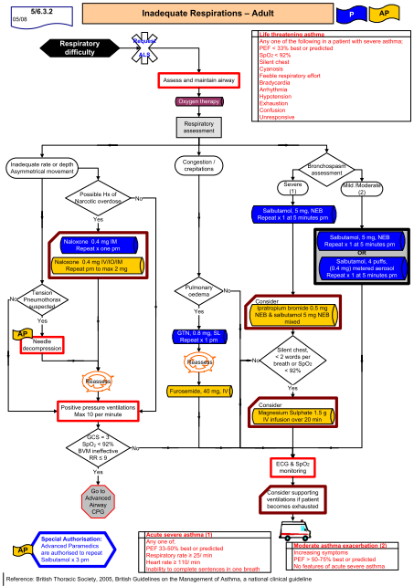
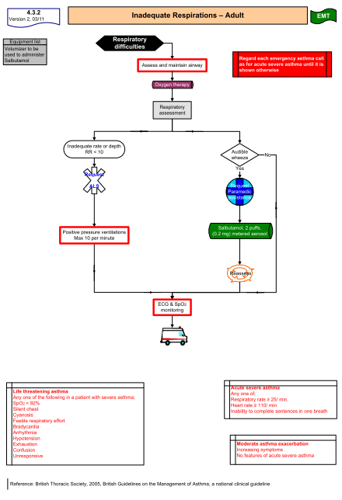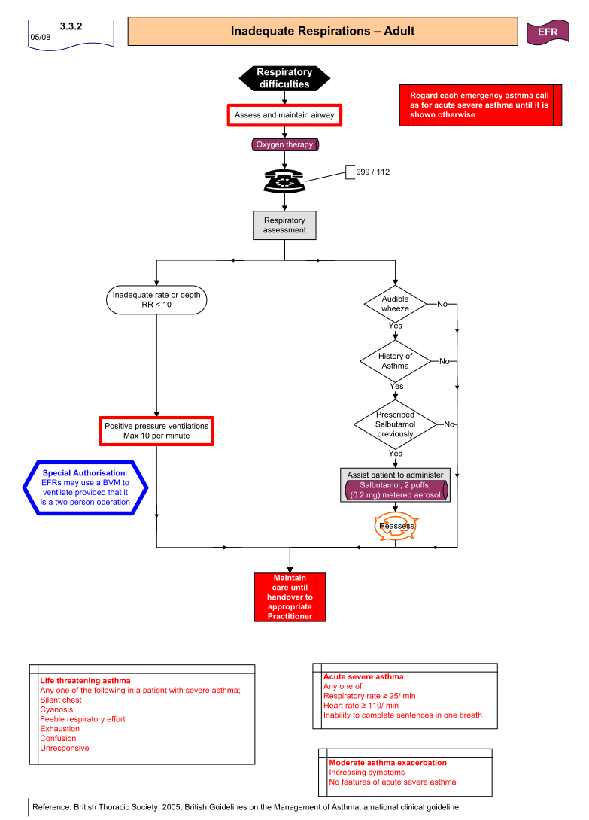

Appendix II – emergency Treatment Care bundles
Adult Asthma Acute Management in General Practice and Primary Care out of hours settings
Assess and Record: Peak expiratory flow; Symptoms and response to self treatment; Heart and respiratory rates; Oxygen Saturation (by pulse oximetry, if available)
Caution: Patients with severe or life threatening attacks may not be distressed and may not have all the abnormalities listed below. The presence of any should alert the doctor
Regard each emergency asthma consultation as for acute life threatening/severe asthma until it is shown otherwise
Date (of review): _________________ Time: ___________________ | Time Processed nurse/physician  Initials Comments
- Give Oxygen via face mask if available, 40 – 60%
If Moderate Exacerbation (PEF 50-75%):
- Give 2 via spacer 6 - 10 puffs (given one at a time and inhaled separately) at intervals of 15 - 30 minutes

If Severe/Life threatening (< 50%):
- Administer salbutamol 5mg or terbutaline 10mg oxygen driven nebuliser

If PEF 50-75% predicated/best:
- Administer prednisolone 40 - 50mgs orally or
- IV hydrocortisone 100mgs

All patients who received nebulised 2 agonist, require extended observation period
- Assess response to treatment in 15 minutes post administration of b2agonist, continually observing symptoms
- If NO response arrange immediate admission to Hospital ED /AMU
Dial 112 0r 999
- Administer High Dose 2 agonist and ipratropium 0.5mg via nebuliser
- Stay with patient until ambulance arrives
- Send documentation assessment and referral to hospital
- Ensure patient is given high dose 2agonist via O2 driven nebuliser in ambulance

- If GOOD response, the Patient’s symptoms improve
- Continue step up of usual treatment and continue course of oral predsnisolone
- Ensure the patient has a prescription for 2agonist and inhaled steroid (if not already on inhaled steroids) prior to discharge
- Commence PEF diary and encourage charting symptoms in the asthma management plan
- Check technique of use inhaler □ and Peak flow meter □
- Demonstrate inhaler technique and Peak flow use to new patients and carer as appropriate.
- Arrange GP follow up in 48 hours

Adult Acute Exacerbation of Asthma in the pre-hospital environment
Life Threatening Asthma
PEF < 33% best or predicted OR any one of the life threatening asthma features:
SpO₂ <92%, Silent chest, cyanosis, poor respiratory effort, bradycardia, arrhythmia, hypotension, exhaustion, confusion, coma.
Patient should be monitored continuously.
Date: _______________ Time: ________________ | Time Processed Practitioner Comments
Give high concentration Oxygen (60%) to maintain SpO₂ greater than 92%
Continuous salbutamol 5 mg + ipratropium 0.5 mg by oxygen driven (6- 8L/min) nebulizer (within 5 minutes of arrival) until improvement from above
Cardiac monitor, Pulse oximetry and Insert IV line
Assess need for non invasive ventilations,
If poor or no response
Magnesium 1.5 g IV in 100 mL Normal Saline over 20 minutes
12-lead ECG
Blood glucose

Table for Approved Medications Administration
Medication | EMT | Paramedic | Advanced Paramedic
Oxygen | √ | √ | √
Salbutamol aerosol | √ | √ | √
Salbutamol nebules |  | √ | √
Ipratropium |  |  | √
Magnesium |  |  | √

Exacerbation of Adult Moderate/Severe Asthma in the pre-hospital environment
Moderate/Server Asthma Features
Severe: PEF < 33 - 50% best or predicted, SpO₂ ≥ 92%, cannot complete sentence in one breath, pulse > 110, Respiration rate > 25.
Moderate: PEF > 50% best or predicted, SpO₂ ≥ 92%, talks in phrases, pulse > 110, Respiration rate < 25.
Patient should be monitored.
Date: _______________ Time: ________________ | Time Processed Practitioner Comments
Baseline Peak flow reading
Oxygen to maintain SpO₂ greater than 92%
Salbutamol 5 mg +/- Ipratropium 0.5 mg by oxygen driven (6- 8L/min) nebulizer
Or
Salbutamol 4 puffs (0.4 mg) by MDI with spacer device
Cardiac monitor, Pulse oximetry and consider IV line
Reassess patient at 10 minute intervals post initial treatment.
If good response, maintain monitoring during transport.
If incomplete response or symptoms persist
Salbutamol 5 mg (may repeat up to 3 times) or Salbutamol aerosol 4 puffs (may repeat up to 3 times)

Table for Approved Medications Administration
Medication | EMT | Paramedic | Advanced Paramedic
Oxygen | √ | √ | √
Salbutamol aerosol | √ | √ | √
Salbutamol nebule |  | √ | √
Ipratropium |  |  | √

Appendix III - Discharge Letter, Fax, Email Template

Discharge Letter following acute asthma Exacerbation to Emergency Department / Hospital

Hospital Name

Patient Name: DOB: ___________

Address____________________________________________________________________

Date /time ___________________________________

Dear GP’s Name_____________________________________________________________

Age: Height Predicted Peak Flow:

 | Initial assessment | On discharge
PEF
Spa O₂
Pulse
Respiratory rate

We have discussed
⁯ Inhaler use / technique with (type) ………………………………………………….
⁯ Medicines including side effects …………………………………………………….
⁯ Trigger avoidance ……………………………………………………………………..
⁯ Smoking cessation ……………………………………………………………………
⁯ How to recognise worsening asthma and what to do in asthma attack: …
Was given a leaflet detailing a simple management plan (copy enclosed)………….
……………………………………………………………………………………………

Other important issues discussed:
1..……………………………………………………………………………………………
2…………………………………………………………………………………………….
3……………………………………………………………………………………………..
………………………………………………………………………………………………………………………………………………………………………………………………

They have been given written information about asthma management

They have been referred to:
Asthma Nurse Specialist …………………………………………………………..
Respiratory Consultant …………………………………………………………….
Other ……………………………………………………………………………….

For follow up appointments.
They have been discharged on the following medications:

Contact Details: Accident & Emergency Department
Signature: Hospital
Name:
Title:
Bleep:

Appendix IV – Audit Form for emergency Asthma Care

Audit Form for Emergency Asthma Care
Patient Name:……………………………………………………………..
DOB: …………………………………… Date/Time:……………………………………
 | Yes | No | N/A
- PEF on admission and after treatment (in anyone over 5 years)
- Pulse rate, respiratory rate and SpO₂. Where SpO₂ < 92% check arterial blood gases and give oxygen as appropriate
- Inhaler technique checked and recorded
- Relevant past medical history recorded (asthma and atopy in particular)
- Triggers identified and avoidance discussed
- Current medicines recorded, including dose, frequency (or their absence) recorded
- Concordance issues addressed
- Psycho-social or other risk factors
- Stable on four hourly treatment or when PEF >75% of best or predicted
- Steroid tablets given as appropriate, as per GINA guidelines
- Provided written information and action plan
- Follow-up with GP for 48 hours after discharge arranged and discharge letter sent
Where you have ticked N/A (not applicable) please explain here e.g. No Peak flow as under 5

Appendix V - Asthma Management Plans
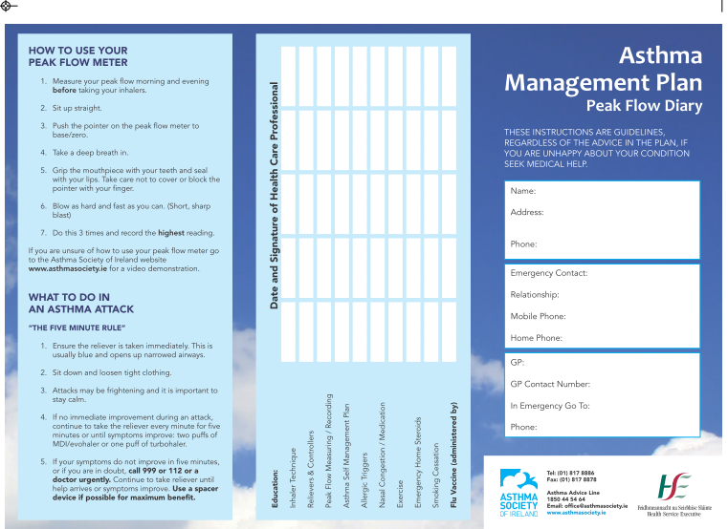
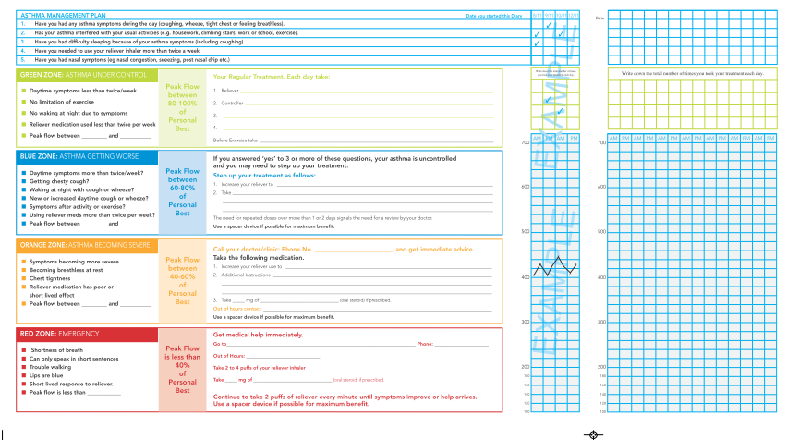

Appendix VI – Peak Flow Measurements

Source: HSE/ IARS National Standards for Peakflow; Measurement, Recording and Analysis of Peak Flow Records; A guide for Healthcare Professionals (2011)

Appendix Vii – medications in acute asthma

Appendix VIII – acknowledgements

National Asthma Programme Working Group
National Clinical Programme Lead | Dr Pat Manning, Respiratory Consultant, Mullingar Regional Hospital
ICGP Lead | Dr Dermot Nolan, General Practitioner, Tramore Medical Clinic, Waterford
Public Health Specialist | Ina Kelly, Consultant in Public Health, HSE, Tullamore
Patient Organisation | Dr Jean Holohan, CEO Asthma Society of Ireland
Clinical Nurse Specialist (Adult) | Anne Tooher, Mullingar Regional Hospital
Clinical Nurse Specialist (Children) | Niamh O’Regan, Mullingar Regional Hospital
Professional Development Coordinator for Practice Nurses | Rhonda Forsythe, PNDC, HSE
Nursing Service Planner | Marian Wyer, Tullamore General Hospital
Respiratory Scientists | Maria McNeill, Respiratory Scientist, Mullingar Regional Hospital  Tom Kelly, Respiratory Scientist, Mater Misericordiae Hospital, Chair of IARS
Allied Health Representative | Joanne Dowds, Senior Physiotherapist, St.James Hospital
Health Intelligence Unit | Davida DeLaHarpe, Head Health Intelligence Unit, HSE QCCD  Anne O’Farrell, Health Intelligence Unit, HSE QCCD
Irish Pharmacy Union | Pamela Logan, Director Pharmacy Service, IPU
Pharmacist | Kathleen Niamh Buckley, Trinity College Dublin
Regional Leads and RCPI/ITS Clinical Advisory Group
Regional Lead DNE | Dr John Faul, Respiratory Consultant, Connolly Hospital
Regional Lead DML | Prof Stephen Lane, Respiratory Consultant AMNCH
Regional Lead South | Dr Terry O’Connor, Respiratory Consultant, Mercy University Hospital, Chair of the Irish Thoracic Society
Regional Lead West | Dr Robert Rutherford, Respiratory Consultant, Merlin Park Hospital
RCPI / ITS Clinical Advisory Group | Regional Leads and the following RCPI/ITS Nominees  Dr Aidan O’Brien, Respiratory Consultant, Mid Western Regional Hospital Limerick  Dr Barry Linnane, Respiratory Consultant, Mid Western Regional Hospital Limerick  Dr Bazil Elnazir, Paediatric Respiratory Consultant, Adelaide Meath and National Children’s Hospital, Tallaght  Dr Des Murphy, Respiratory Consultant, Cork University Hospital
Consultative Groups
National Emergency Medicine Programme | Dr Una Geary, ED Programme Lead, Consultant in Emergency Medicine, St. James Hospital  Prof. Ronan O'Sullivan, Head of Paediatrics, School of Medicine & Medical Science, UCD , Consultant in Paediatric Emergency Medicine Our Lady's Children's Hospital Crumlin
National Acute Medicine Programme | Dr Garry Courtney, Acute Medicine Programme Lead, Clinical Director, St Lukes Hospital Kilkenny  Prof Shane O’Neill, Acute Medicine Programme Lead, Respiratory Consultant, Beaumont Hospital
National Paediatric Programme | Prof Alf Nicholson, Consultant Paediatrician, Children’s University Hospital, Temple Street
Pre-Hospital Emergency Care Council | Dr Geoff King, Director, Pre-Hospital Emergency Care Council
International Asthma Advisor  Chairman of Scientific Committee GINA | Prof Mark Fitzgerald, Professor of Medicine, Head, UBC and VGH Divisions of Respiratory Medicine, Director, Centre for Lung Health, The Lung Centre, Vancouver, Canada
ICGP | Quality in Clinical Practice Committee

