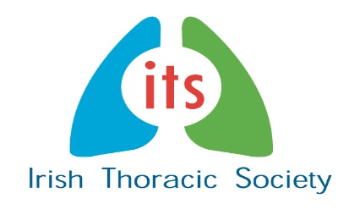

ITS Case Study Forum
The ITS Case Study Forum will take place on the evening of Thursday 21st November 2019 in the Galmont Hotel, Galway. You are invited to submit abstracts of case studies for consideration for oral or poster presentation during this session. Case reports will be accepted from all disciplines and levels of training.

- The abstract must not exceed 100 words - excluding the title, authors(s) name(s), address(es), and any references.

- Please submit by email to cases@irishthoracicsociety.com by (insert date)

- There will be awards for the best poster abstract and an award for the best oral presentation.

- Please note case study abstracts should not be sent through the website abstract submission system but by email to the above address only.

