SEPA Direct Debit Mandate
Please complete this form to instruct your bank to make payments directly from your
account. Then return the form to:

The Irish Thoracic Society, Creidim Centre, Leopardstown Road, Dublin 18, D18 FF64.

SEPA Direct Debit Mandate  *Unique Mandate Reference _____________________________ | 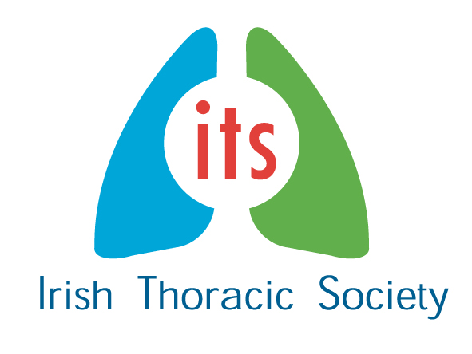
*Creditor Identifier: IE53ZZZ305501
Legal Text: By signing this mandate form, you authorise (A) The Irish Thoracic Society to send instructions to your bank to debit your account and (B) your bank to debit your account in accordance with the instruction from The Irish Thoracic Society.
As part of your rights, you are entitled to a refund from your bank under the terms and conditions of your agreement with your bank. A refund must be claimed within 8 weeks starting from the date on which you account was debited. Your rights are explained in a statement that you can obtain from your bank.
Please complete all the fields below marked *
_____________________________________________
*Your Name : _____________________________________
Address Line 1________________________________________
Address Line 2________________________________________
Your Address:

*City/postcode __________________ * Country:
_________________________
* Account number(IBAN)
*Swift BIC

Creditors Name and Address
The Irish Thoracic Society
Creidim Centre, Leopardstown Road,
Dublin 18, D18 FF64.

*Type of payment Recurrent or One-Off Payment (Please tick √)

*Date of signing:

*Signature(s)

